ESL CHILDRENS HALLOWEEN PARTY 31st October

4.30pm at The Kiosk

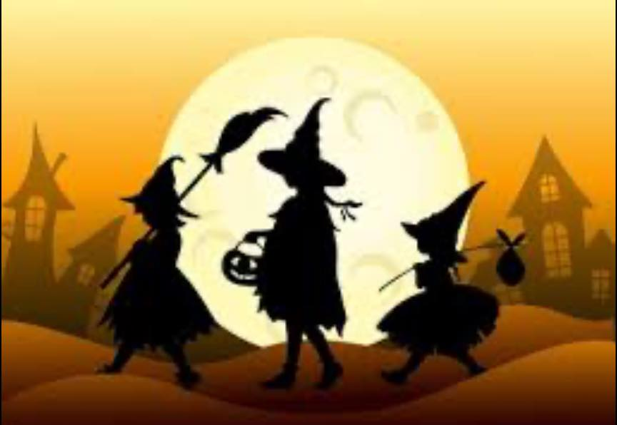

ESL RESIDENTS, FAMILY & FRIENDS

All junior witches & wizards should be accompanied by an adult please

“SPOOKY MUSIC”

HOT DOGS & DRINKS FOR THE CHILDREN

FANCY DRESS OPTIONAL

SPOOKY GAMES

Prepare to be spooked BEFORE YOU GO TRICK OR TREATING!!

**No charge but please bring money for “My Sisters House” charity collection**